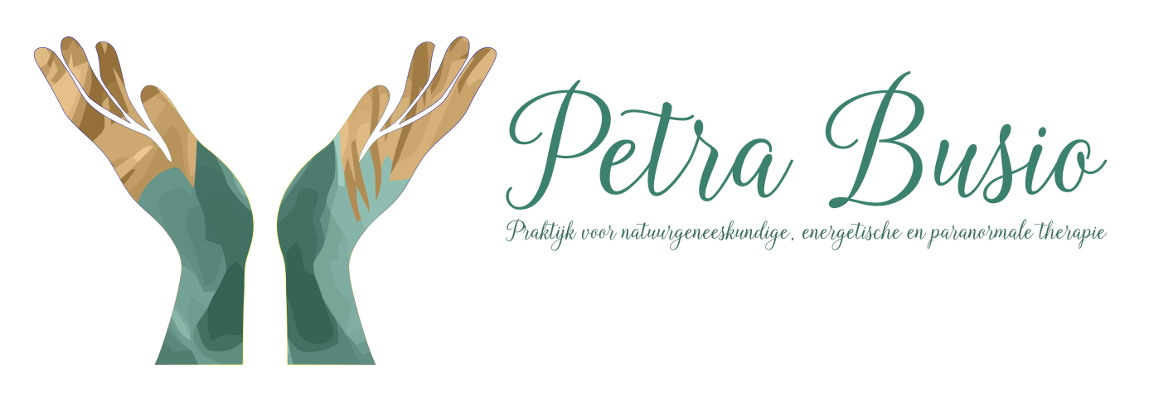
Automatic Writing
& Meeting with your guide.
Work out soul goals and communicate with entities.
Zandheuvel 59 4901HV Oosterhout NBr
Tel: 0610564703
www.petrabusio.nl
info@petrabusio.nl
Short workshop 2 hours.
2020

What are guides? Everyone has a birth guide, who guides you to reach your soul goal. Sometimes you have several guides and / or helpers. Your birth guide helps you write. The more contact you make with your birth guide, the stronger the contact with your other guides and helpers becomes. Your guide for love gives you a nice feeling of love when you make contact with this guide.
What is a Channel? Channels are used for communicating with spiritual persons. It is one of the most interesting phenomena in the paranormal world.
The history. Channeling is a mystical experience, a phenomenon, that is as old as humanity. Fortune tellers, shamans, prophets and initiates were already working on it. Such as Jesus, Moses and Nostradamus and Jozef Rulof. It was used in all eras and cultures.
Workshop. The workshop consists of three parts, Theory, Meditation, Writing. Love, honesty and acceptance will be the main focus.
The spirit world. Spirits do not have a physical body, are very quick in understanding issues, and have paranormal abilities on the other side. Even if they didn't have these abilities before. They can therefore bring about all kinds of psychic phenomena.
Energy. Energy is everywhere and the spirit world is also everywhere, and everything is energy. So you can communicate with everything. So also with animals, plants, objects, places, trees, entities. Automatic writing usually happens when you approach a person through the soul.
The benefits of writing?
- You feel that you are part of the universal Love.
- Through our guides we will get to know ourselves better.
- Learning to discover and support your soul goals.
- The separation between the entities and the person is abolished.
- Psychological problems are seen in a different light.
- Health and your insight on it will be guided by healing.
Suitable for writing?
- Learn to understand the spirit world.
- Good motivation
- Free up enough time for it.
- Do not use it to try to resolve problems that are too big
- Want to work in love
- Work in honesty, purity.
- Your body must flow pretty well and be in the lifeline.
The first contact.
Your guide may first teach you how to write, it will first start very simply. Take the time for it and above all let love be the basis of contact. In the beginning it will seem strange and it will even seem like you are doing it yourself, like the text you are writing is made up by you. But if you ask questions that you actually don't know yourself, you will get confidence in the fact that your guide is helping you. The most important part of automatic writing is nota bout the knowledge, but about the love that you feel when you are writing.
Dear ... please write with me (date).
That will be your first sentence when writing. Surrender yourself completely. Move your thoughts aside and let the energy write. It will come in where the angel's wings are. Don't let your guide make you doubt. And trust that it will work. You did not end up here, at this place, for nothing. The guide has sent you here for a reason. Optimism and positive thinking is very important at the first start. You start by learning to write the alphabet together, the letters will carefully come in waves. Having the motor controlled by your guide is very difficult in the beginning, so discipline and perseverance are needed. A private place where you can write undisturbed is also nice to have. Ask for short answers such as a yes or beautiful.
Sensations such as a vibration, feeling cold or, on the contrary, warmth may also arise at first.
Does your guide actually want to communicate in this way? In the beginning it takes a while to figure this out.
Sometimes it happens that you can immediately write well and quickly, and then you will need time to process that. You can fit your guide into your life and it takes time and space to do so, and on the other side they also do have more time available than we do.
Half an hour of writing and then take a break. Rest first and then write.
Make sure you are properly grounded. That is of the utmost importance. If you stop writing you always need to thank your guide.
Your guide can also help you heal yourself.
Warning!
- Put a light barrier around you before you start writing.
- Always request your own guide first.
- Ground well
- You always remain the boss.
- Always keep thinking for yourself.
- Your guide is your helper, we cannot put him higher than yourself in equality.
- Guides have all the time and space, we do not.
- Always continue to treat your fellow humans with respect, so watch out with predicting the future.
- It's about the relationship between your guide and you.
- Do not work with a battle ax, but only with pure love.
- Also be kind to your fellow humans in the word, always read your writing aloud.
- You need to be aware of what you wrote.
What can you expect?
- Take your own responsibility, you decide how you want to live your life.
- Half an hour a day is enough to channel.
- There is no time and space in the spirit world, keep that in mind.
- The future is constantly changing for the spirit world as well.
- Do not let yourself be dominated, guidance is beautiful and enough.
- The spirit world is different from our world, our understanding of this world must still grow and develop.
- They never tell untruths, but it differs from human reality.
- If you don't know what to ask, ask about their world, they like that.
- You are not the “chosen one”, as they will say to you. Because that is nobody.
- Making contact is LOVE.
- They do not know everything. Your guide sometimes doesn't want to say something or doesn't know everything. Understand this.
- Your guide is connected with Jesus and with higher beings, you can also make contact with Jesus but first make contact with your own guide.
Good luck.
And especially enjoy, Petra Busio

